**About**

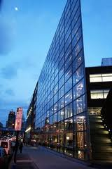The Electrochemical Energy Systems Laboratory (ECSL) was established in the Mechanical Engineering and Mechanics Department at Drexel University, Philadelphia in 2009 by Dr. Emin Caglan Kumbur. The core mission of ECSL is to advance the science and technology necessary to develop next generation electrochemical energy systems, in particular flow batteries, supercapacitors, and fuel cells for automotive, stationary, and portable applications.

Due to the nature of these electrochemical systems, research at ECSL is highly interdisciplinary. We utilize a comprehensive approach, including: advanced performance diagnostics, system/component design, imaging, materials characterization, and computational modeling of these electrochemical systems. The ECSL team has been growing rapidly, embodying researchers at both the graduate and undergraduate level. Due to the highly interdisciplinary nature of the research, our team consists of individuals with expertise in mass/heat transport, electrochemistry, materials science, chemical kinetics, reacting flows, and experimental design and testing. Team members have access to a vast array of equipment and the state-of-the-art facilities at Drexel.



Please browse our website to learn more about our research activities, publications and facilities. We do our best to frequently update our website. Please feel free to contact Dr. Kumbur if you would like to learn more about ECSL.

**Research**

The core mission of ECSL is to develop novel diagnostic and computational tools to understand critical issues in flow-assisted electrochemical systems and enable better system design. Due to the complex nature of these systems, our research is highly interdisciplinary and spans the interface of transport phenomena, materials characterization, electrochemistry and system engineering. Our core research activities are categorized into three thrusts, i) materials characterization, ii) computational studies and iii) performance diagnostics and system design.

1. **Microstructure Analysis and Characterization:** Our efforts in this thrust are focused on understanding the internal structure of materials, providing benchmark data for modeling studies, and guiding component design efforts. In particular, we are interested in determining the difficult-to-measure structure-related transport properties of next generation materials and establishing structure-performance linkages for these electrochemical systems.
2. **Computational Studies of Electrochemical Systems:** Our efforts in this thrust are aimed at exploring physicochemical phenomena that take place in these systems and establishing links between theory and practice. In particular, we develop experimentally validated multi-scale electrochemical models that utilize the wealth of microstructure information and enable simulation of operation of these electrochemical systems under a wide range of operating conditions to better understand the key issues governing performance loss in these devices.
3. **Performance Diagnostics and System Design:** Our efforts in this thrust are toward developing novel in-situ and ex-situ diagnostic tools and conducting performance testing to identify the major losses, characterize system performance, and provide benchmark data for modeling studies. We perform in-situ and ex-situ analysis at both component and system levels to guide component/system design efforts.

Currently, the research activities in ECSL are primarily focused on three technologies:

* 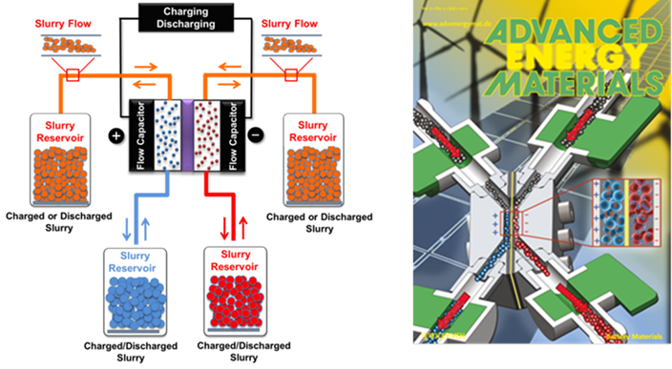**Electrochemical Flow Capacitor (EFC):** TheEFC is a new energy concept that we have developed in collaboration with Prof. Yury Gogotsi’s group at Drexel.This new capacitor concept takes the advantages of both supercapacitors and flow batteries. It enables rapid charging/discharging (i.e., fast system response) with high power, while providing decoupled energy storage and power output (i.e., scalable energy storage capacity). The unique aspect of this new concept is the use of flowable carbon-electrolyte slurries for capacitive energy storage. For more information, please look at our publications or contact Dr. Kumbur.

Our current efforts on EFCs include: flow cell design, component development, performance benchmarking, investigation of carbon materials, slurry preparation and synthesis, prototype development, and detailed techno-economical analysis of this technology.

* 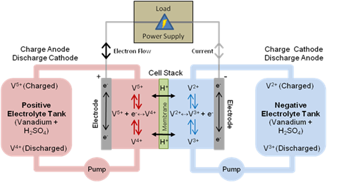**Redox Flow Batteries (RFBs):** Recently, RFBs have emerged as a promising energy storage technology due to their flexible design and ability to efficiently store energy. Unlike traditional batteries, the key advantage of RFBs is that power generation and energy storage are decoupled, such that the energy storage capacity is determined by the size of the electrolyte tanks, whereas the power rating is dictated by the size and number of redox cells.

We are currently working on various aspects of RFBs, including: transport phenomena in RFB membranes, capacity fade and mitigation strategies, electrolyte synthesis, new electrode architectures, electrode treatment and functionalization, understanding the transport related losses, electrolyte flow management, and long-term performance analysis.

* 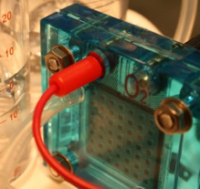**Polymer Electrolyte Fuel Cells (PEFCs):** Due to their potential for high power density and efficiency, fuel cells remain at the core of our research activities.We are particularly interested in PEFCs due to their unique advantages and wide range of application areas. Currently, our research on PEFCs is aimed at assessing the role of the internal structure of materials on the water/thermal management, performance, and durability of these systems. We perform experimental and computational studies to analyze different materials and understand the fundamental mechanisms responsible for performance loss in these systems

**Facilities**

The ECSL is located in the Science Center Research Complex adjacent to Drexel’s University City Campus, and encompasses approximately 1500 sq ft of space equipped with two fume hoods. The laboratory is equipped to perform advanced performance diagnostics of static and flow-assisted electrochemical systems and conduct a wide variety of performance diagnostics, wet chemistry, synthesis, manufacturing procedures, and computational studies.

Some of the major equipment in ECSL includes: a fully automated redox cell test system for testing of static and flow-assisted electrochemical devices, a high-temperature fuel cell testing station, a potentiostat/galvanostat configured with multiple channels and current booster, a high performance modeling workstation with dual hex-core Intel Xeon processors and 96 GB of RAM, a TAIG Tools Micro Mill DSLS 3000 vertical CNC milling machine, an electrochemical flow capacitor testing station, a Carbolite CTF 17/25/300 tube furnace capable of up to 1700°C, and several peristaltic and syringe pumps. ECSL also has a complete wet lab setup including two chemical fume hoods, a precision micro-balance, ultrasonicator, stirring hot plates, and high performance computer workstations with COMSOL, Abaqus, ANSYS, Pro/ENGINEER, AutoCAD, and MATLAB.

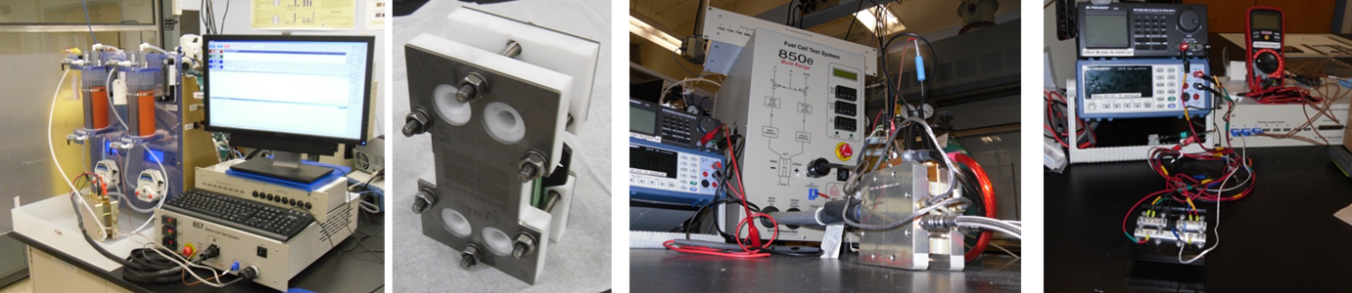

**Drexel Centralized Research Facilities**

Additional tools are available through the Centralized Research Facilities at Drexel University. The CRF at Drexel University houses state-of-the-art analytical, imaging, and micro-fabrication facilities. Equipment available at the CRF includes several scanning electron microscopes (SEM), an environmental scanning electron microscope (ESEM), Raman micro-spectrometers, optical profilometer, transmission electron microscope (TEM), dual-beam forced ion beam scanning electron microcope (FIB-SEM,) x-ray diffraction (XRD), nano-indentation, microfabrication, x-ray computed microtomography (XCT) and other characterization equipment. Microfabrication equipment includes inductively-coupled plasma deep reactive ion etching, e-beam and thermal evaporators, optical profilometry, and photolithography equipment. The ECLS Team has access all the equipment in this facility

For more information about the CRF, please visit <http://crf.coe.drexel.edu/>

**Drexel Machine Shop**

The Drexel machine shop is located in the Hess Research Complex. This full service machine shop includes 5 manual Bridgeport vertical mills and a Haas vertical CNC mill, 5 manual horizontal lathes and a Haas horizontal CNC lathe, a Brother electrical discharge machining (EDM) machine, a Versa Laser cutter, a Dimension Elite rapid prototyping machine, and a full welding and finishing setup. Our team members have access to all equipment in the Drexel Machine Shop.

**Position**

Our team is composed of a group of motivated students at all levels with diverse backgrounds.  Ph.D. and Post Doc positions are available based on the needs of ongoing projects and the availability of funding. If you are interested in joining us, please contact Dr. Kumbur regarding available positions. Undergraduate students who are interested in our research are also highly encouraged to contact Dr. Kumbur. We have a group of undergraduate researchers currently working on different projects.

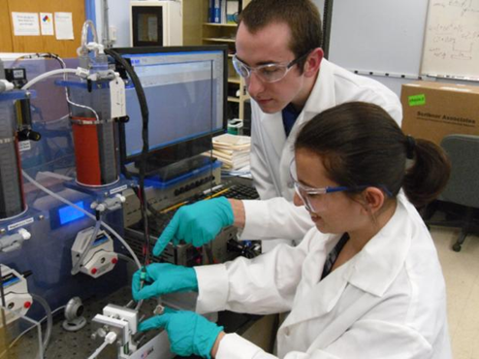

Drexel is located in the heart of Philadelphia, PA, a vibrant city with a strong industrial base in aerospace, biotechnology, chemicals, and pharmaceuticals. The city is rich in history, with a wealth of cultural attractions. Philadelphia has the world's largest municipal park, world-renowned science and art museums, a world-class music and theater scene, and many vibrant and lively neighborhoods. We are a short train ride or drive from New York City, Washington, D.C., the Atlantic seaboard, the Pocono Mountains, and numerous other educational and recreational sites.

